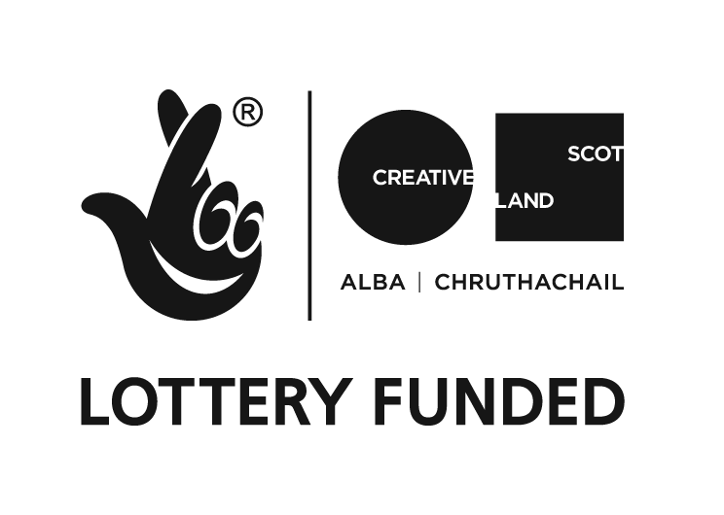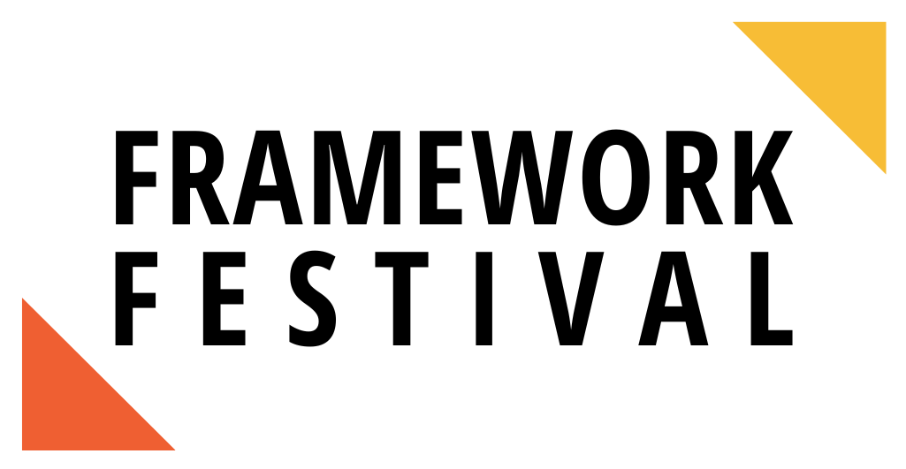

**Scratch Casting Call**

*If you require this information in another format or have any questions please contact hello@frameworktheatre.com.*

Framework Theatre Company are thrilled to present **Framework Festival 2025**. Now in its fifth year, Framework Festival aims to provide a regular offering of support to all emerging artists in Scotland. It provides time, space, and knowledge to artists and facilitates connection across the sector.

This year the in-person part of the festival will be a day of panels, workshops, and new writing at the **Traverse Theatre on the 17th May 2025**. This festival is designed for emerging artists to **create** new work, **support** emerging artists with their creative development, and **connect** with other emerging creatives.

We are seeking **five emerging/early-career performers** to each present one of two 15-minute play excerpts at the Traverse Theatre on the 17th May 2025. Each play will get an hour of rehearsal on the day facilitated by an emerging director, and will be then performed scratch-style, script-in-hand, in front of the Framework Festival audience at the Traverse Theatre.

Framework Festival 2025 is funded by the National Lottery via Creative Scotland.

**About Framework Theatre:**

Framework Theatre is a charity run by emerging theatre-makers, for emerging theatre-makers. We support the development of early-career artists in Scotland. We aim to create new work championing underrepresented new voices and developing new routes into the sector. We prioritise access, diversity and fair work across our projects.

For information on our recruitment protocol, access our policy[**here**](https://www.frameworktheatre.com/our-documents).

**Essential Criteria:**

* Must self identify as an emerging/early-career performer.
* Must be permanently based in Scotland (this should be your main base, not a secondary one).
* Must be 18+.

**Commitment:** Attendance at Traverse Theatre on 17th May 2025.

**Fee:** £150 + Holiday Pay totalling £168.11 (for 1 day attendance on the 17th May at £150/day)

**Access & Travel Support Provided Within Scotland**

**Decision-Making Process:**

Applications will initially be shortlisted by the core Framework Team. A shortlist for each track will then be sent to the relevant director who will have final say.

**Roles:**

**Track 1 - LEXI: 25, Scottish, Woman (she/her)**

Waitress at Bread Meets Bread and aspiring fashion photographer. Down-to-earth with a fiery personality and colourful language.

**Track 2 - ROISIN: 24, Irish, Woman (she/her), preference for Global Majority Performers**

Enterprise Leadership Graduate with a first in Mathematics from Edinburgh University. The rational, organized one of the group.

**Track 3 - MARIA ELENA: 26, Spanish, Woman (she/her)**

Painter who works at a fresh food grocer to pay the bills. Artistic, spiritual, and passionate.

**Track 4 - OPHELIA (Lea), 30s, Woman (she/her)**

An architect at a high level firm in Toronto.

**Track 5 - SEBASTIAN (Ash - deadname: Viola), 20s, Non-Binary (they/them)**

A manager in an independent queer bookstore in Toronto.

Please note we are only interested in hearing from non-binary performers for this role.

**To Apply:**

* **Read this document** carefully, especially the track descriptions.
* Submit the following at <https://forms.gle/3LyxJH6Ks2u1f9kcA>by **10am on Friday 2nd May 2025.**
* A link to a **tape of performance work** uploaded to YouTube, Spotlight or Vimeo.

This should be a tape/showreel that gives us a sense of your ability to portray the tracks you are submitting for. We recommend this contains two contrasting pieces (particularly if submitting for more than one track), however can be a single monologue/scene.

Our hope is that this should be something you have on hand, to minimise unpaid workload.

* A link to your **performance CV**. This can either be a link to your Spotlight, or an uploaded document.
* The form will also ask for a few details including name, which track you wish to be considered for and where you are based.